Lab 12

Configuring a Network Policy Server

This lab contains the following exercises and activities:

|  |  |
| --- | --- |
| Exercise 12.1 | Installing and Configuring Network Policy Server |
| Exercise 12.2 | Configuring NPS for RADIUS Server for VPN Connections |
| Exercise 12.3 | Managing RADIUS Templates |
| Exercise 12.4 | Configuring RADIUS Accounting |
| Lab Challenge | Add Workstation Authentication Certificates to All Workstations |

BEFORE YOU BEGIN

The lab environment consists of student workstations connected to a local area network, along with a server that functions as the domain controller for a domain called *contoso.com*. The computers required for this lab are listed in Table 12-1.

Table 12-1

Computers Required for Lab 12

|  |  |  |
| --- | --- | --- |
| Computer | Operating System | Computer Name |
| Server (VM 1) | Windows Server 2012 | RWDC01 |
| Server (VM 2) | Windows Server 2012 | Server01 |

In addition to the computers, you also require the software listed in Table 12-2 to complete Lab 12.

Table 12-2

Software Required for Lab 12

|  |  |
| --- | --- |
| Software | Location |
| Lab 12 student worksheet | Lab12_worksheet.rtf (provided by instructor) |

Working with Lab Worksheets

Each lab in this manual requires that you answer questions, shoot screen shots, and perform other activities that you will document in a worksheet named for the lab, such as Lab12_worksheet.rtf. You will find these worksheets on the book companion site. It is recommended that you use a USB flash drive to store your worksheets, so you can submit them to your instructor for review. As you perform the exercises in each lab, open the appropriate worksheet file using WordPad, fill in the required information, and save the file to your flash drive.

After completing this lab, you will be able to:

* Install and configure Network Policy Server
* Configure RADIUS clients
* Manage RADIUS templates
* Configure RADIUS accounting

Estimated lab time: 65 minutes

|  |  |
| --- | --- |
| Exercise 12.1 | Installing and Configuring Network Policy Server |
| Overview | In this exercise, you install and configure Microsoft’s RADIUS server known as *Network Policy Server*. |
| Completion time | 15 minutes |

**Mindset Question: During this lab, you install and configure the Network Policy Server. What is the Network Policy Server used for?**

# Installing Network Policy and Access Services

**1.** Log in to RWDC01 as the **Contoso\Administrator** user account. The Server Manager console opens.

**2.** On Server Manager, select Manage and click Add Roles and Features. The Add Roles and Features Wizard opens.

**3.** On the Before you begin page, click Next.

**4.** Select *Role-based or feature-based installation*, and then click Next.

**5.** On the Select destination server page, click Next.

**6.** On the Select server roles page, select *Network Policy and Access Services*.

**7.** When it asks you to add features that are required for Network Policy and Access Services, click Add Features.

**8.** Back on the Select server roles page, click Next.

**9.** On the Select features page, click Next.

**10.** On the Network Policy and Access Services page, click Next.

**11.** On the Select role services page, with the Network Policy Server selected, click Next.

**12.** On the Confirm installation page, click Install.

**13.** When the installation is complete, click Close.

# Adding a Remote RADIUS Server Group

**1.** On RWDC01, with Server manager, click Tools > Network Policy Server. The Network Policy Server console opens.

**2.** Expand the Network Policy Server console to fill the entire screen.

**3.** In the console tree, double-click RADIUS Clients and Servers, right-click Remote RADIUS Server Groups, and then click New. The New Remote RADIUS Server Group dialog box opens.

**4.** In Group name, type **RADIUS Servers** in Group name text box. Click Add. The Add RADIUS Servers dialog box opens as shown in Figure 12-1.

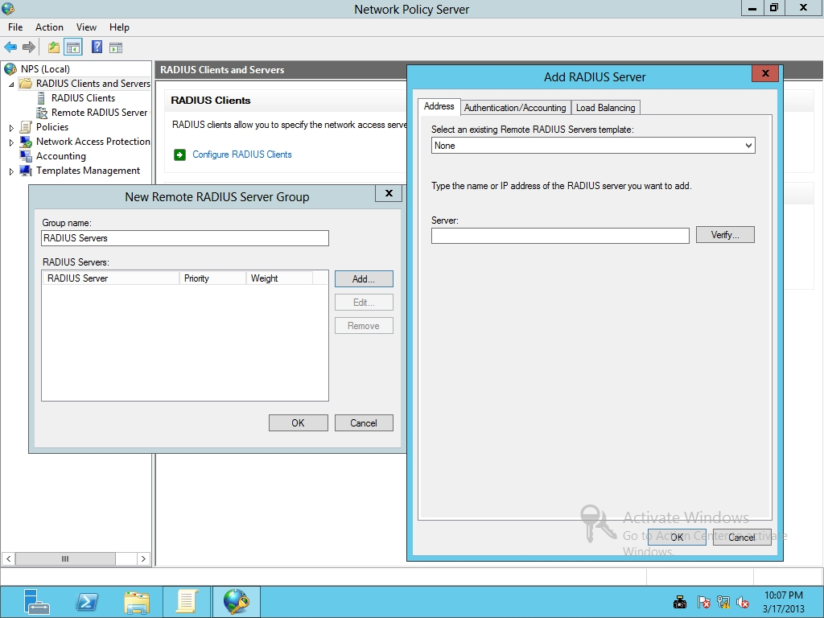

Figure 12-1

Adding a RADIUS server

**5.** In the Server text box, type the IP address of RWDC01, **192.168.1.50**.

**6.** Click the Authentication/Accounting tab.

|  |  |
| --- | --- |
| Question 1 | What is the default authentication port used with RADIUS servers? |

|  |  |
| --- | --- |
| Question 2 | What is the default accounting port used with RADIUS servers? |

**7.** Take a screen shot of the Add RADIUS Server dialog box by pressing Alt+Prt Scr and then paste it into your Lab12_worksheet file in the page provided by pressing Ctrl+V.

**8.** Click OK to close the Add RADIUS Server dialog box.

|  |  |
| --- | --- |
| Question 3 | What is the default weight assigned to the new RADIUS server? |

**9.** Click OK to close the New Remote RADIUS Server group.

**10.** Leave the Network Policy Server console open for the next exercise.

End of exercise. You can leave the windows open for the next exercise.

|  |  |
| --- | --- |
| Exercise 12.2 | Configuring NPS for RADIUS Server for VPN Connections |
| Overview | During this exercise, you configure NPS to support VPN connections. |
| Completion time | 10 minutes |

**Mindset Question: During this lab, you install and configure Microsoft’s RADIUS server. What is a RADIUS client and how does it differ from an access client?**

**1.** On RWDC01, using the Network Policy Server console, click NPS (Local).

**2.** Use the down arrow under Standard Configuration in the main panel, and select *RADIUS server for Dial-Up or VPN Connections*.

**3.** Click Configure VPN or Dial-Up. The Configure VPN or Dial-Up Wizard opens.

**4.** On the Select Dial-up or Virtual Private Network Connections Type page, select *Virtual Private Network (VPN) Connections*. Click Next.

**5.** On the Specify Dial-Up or VPN Server page (as shown in Figure 12-2), click Add.

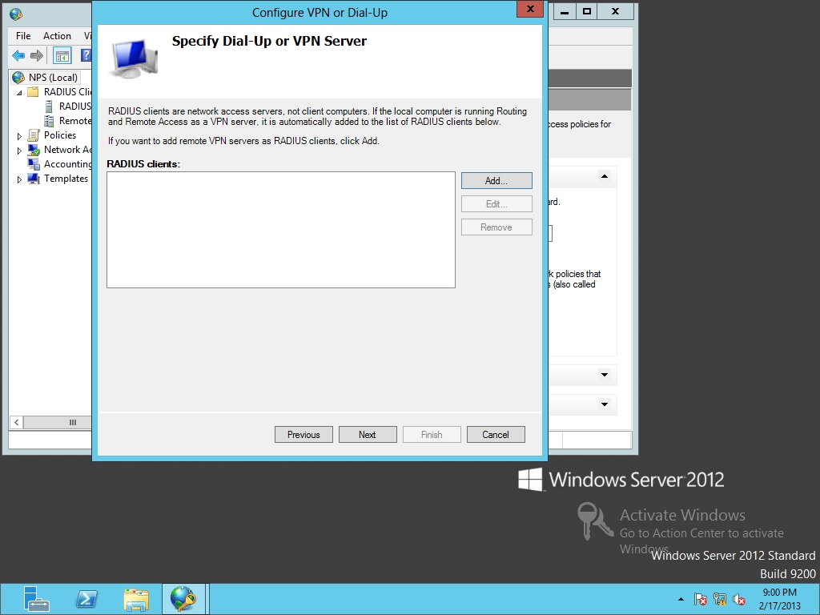

Figure 12-2

Adding RADIUS clients (VPN server)

**6.** When the New RADIUS Client dialog box opens (as shown in Figure 12-3), type **Server01** in the Friendly name text box. In the Address (IP or DNS) text box, type **192.168.1.60**.

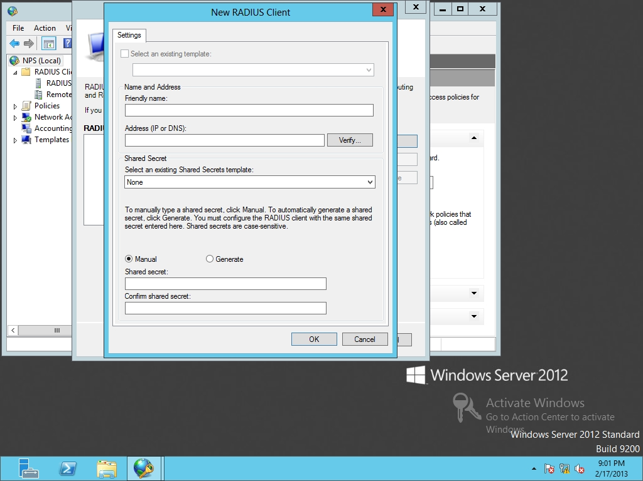

Figure 12-3

Configuring the new RADIUS client

**7.** At the bottom of the dialog box, type **Password01** in the Shared secret and Confirm shared secret text box. Click OK to close the Remote Access Properties dialog box.

**8.** Back on the Specify Dial-Up or VPN Server page, click Next.

**9.** Take a screen shot of the Configure Authentication Methods by pressing Alt+Prt Scr and then paste it into your Lab12_worksheet file in the page provided by pressing Ctrl+V.

**10.** Click Next.

**11.** On the Specify User Groups page, answer the following question, and click Next.

|  |  |
| --- | --- |
| Question 4 | What happens if you do not define a user group? |

**12.** On the Specify IP Filters page, click Next.

**13.** On the Specify Encryption Settings page, click Next.

**14.** On the Specify a Realm Name page, type **contoso.com** in the Realm name. Click Next.

**15.** When the wizard is complete, click Finish.

**16.** Under the Policies node, click the Connection Request Policies node and take a screen shot of the Network Policy Server window by pressing Alt+Prt Scr and then paste it into your Lab12_worksheet file in the page provided by pressing Ctrl+V.

**17.** Leave the Network Policy Server console open for the next exercise.

End of exercise. You can leave the windows open for the next exercise.

|  |  |
| --- | --- |
| Exercise 12.3 | Managing RADIUS Templates |
| Overview | During this exercise, you use RADIUS templates to simplify the deployment of RADIUS in the future. |
| Completion time | 10 minutes |

**Mindset Question: During this exercise, you work with RADIUS templates. What are the benefits of RADIUS templates?**

**1.** On RWDC01, using Network Policy Server console, double-click Templates Management.

**2.** Right-click Shared Secrets and click New. The New RADIUS Shared Secret Template opens.

**3.** In the Template name text box, type **Shared Secret Template**.

**4.** In the Shared secret and Confirm shared secret text boxes, type **Password01** and click OK.

**5.** Under RADIUS Clients and Servers, click RADIUS Clients.

**6.** In the RADIUS Clients pane, double-click Server01. The Server01 Properties dialog box opens.

**7.** In the Shared Secret section, in the drop-down arrow list, select the Shared Secret Template. Click OK.

**8.** Right-click Templates Management and click Export Templates to a File.

**9.** In the File Name text box, type **Templates** and click Save.

**10.** Right-click Templates Management and click Import Templates from a File.

**11.** Scroll down and click Templates.xml, then click Open.

**12.** Leave the Network Policy Server console open for the next exercise.

End of exercise. You can leave the windows open for the next exercise.

|  |  |
| --- | --- |
| Exercise 12.4 | Configuring RADIUS Accounting |
| Overview | Although RADIUS is used for central authentication, it can also be used for accounting. Therefore, during this exercise, you configure RADIUS accounting. |
| Completion time | 5 minutes |

**Mindset Question: What are the two uses of RADIUS accounting?**

**1.** On RWDC01, using the Network Policy Server console, on the NPS tree, click Accounting.

**2.** In the Accounting section, click Configure Accounting. When the Accounting Configuration Wizard starts, click Next.

**3.** On the Select Accounting Options page (as shown in Figure 12-4), click *Log to a text file on the local computer* and click Next.

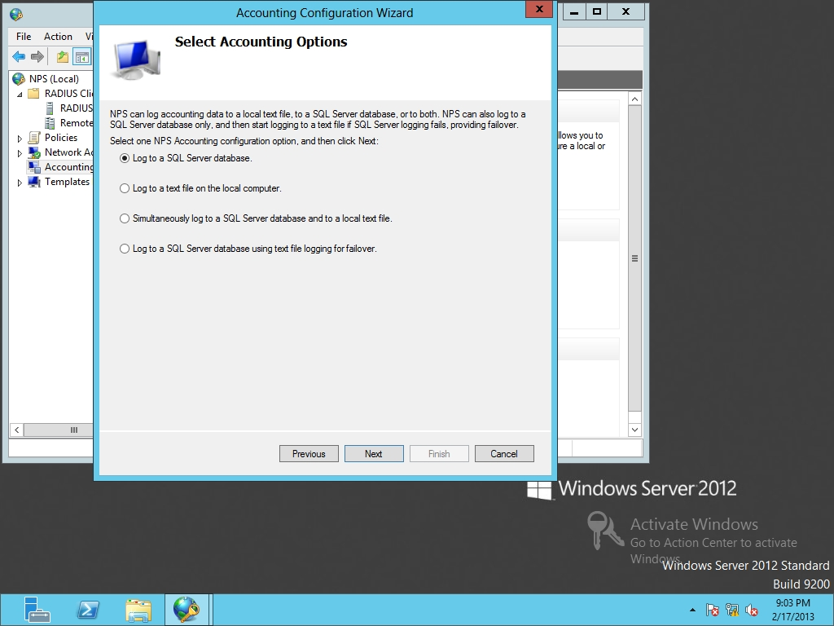

Figure 12-4

Selecting accounting options

**4.** On the Configure Local File Logging page, answer the following question and click Next.

|  |  |
| --- | --- |
| Question 5 | Where are the logs stored? |

**5.** On the Summary page, click Next.

**6.** On the Conclusion page, click Close.

Lab REview Questions

|  |  |
| --- | --- |
| **Completion time** | **10 minutes** |

**1.** In Exercise 12.1, what program is used as the RADIUS server in Microsoft Windows servers?

**2.** In Exercise 12.2, what is a VPN server or wireless access point from the point-of-view of the NPS server?

**3.** In Exercise 12.2, when a user, using his or her laptop, connects to a VPN server, what is the laptop considered when discussing RADIUS?

**4.** In Exercise 12.3, if you decide to deploy several RADIUS servers, what can you use to help manage the deployment and configuration of servers?

**5.** In Exercise 12.4, what are the two methods used to record events used in RADIUS accounting?

|  |  |
| --- | --- |
| Lab Challenge | Add Workstation Authentication Certificates to All Workstations |
| Overview | To complete this challenge, you will demonstrate how to add workstation authentication certificates to all workstations by writing the steps to complete the tasks described in the scenerio. |
| Completion time | 15 minutes |

You decide to use RADIUS for your organization. To ensure a secure environment, you decide to use digital certificates. How would you automatically add workstation authentication certificates to all client computers within your organization?

Write out the steps you performed to complete the challenge.

End of lab. You can log off or start a different lab. If you want to restart this lab, you’ll need to click the End Lab button in order for the lab to be reset.